**DAY 1 Tasks**

* **Finding Elements and various types of locators : Tasks**

**Demo site for practice**  <https://www.amazon.in/>

1)Locate search box and enter any item name and click on search verify same by getting url of page . use all 4 locators id, class name, tag name, name for locating elements.

2)Go to footer of page as shown in image below locate any of link using locators Partial link text , link text click on the link verify if link opens up.Verify using geturl method .

3) practice Xpath axes on various elements (traverse through sibling nodes and parent nodes)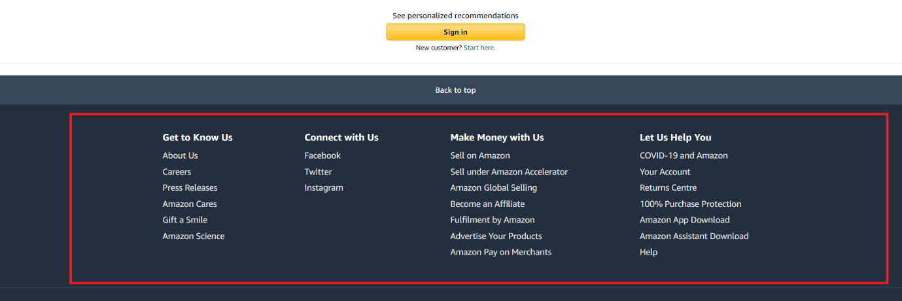

* **Page navigation and maximize : Tasks**

1)click on any link on page then click on back page confirm if we navigated to home page then click on forward page and confirm we navigate to click we clicked previously

2)learn about how to maximize browser window to particular dimension.

**DAY 2 Tasks**

* **CSS selectors**

1. practice locating elements using Css selectors

* **Implicit and Explicit waits**

1)Learn about pageLoadTimeout() and setScriptTimeout().

Refer : <https://www.browserstack.com/guide/understanding-selenium-timeouts>

2)goto below mentioned url and practice explicit waits.

<https://chercher.tech/practice/explicit-wait-sample-selenium-webdriver>

* **JavaScriptExecutor**

1)practice scrolling operations

2) Try to learn about how to scroll into view of element

Refer this : <https://learn-automation.com/how-to-scroll-into-view-in-selenium-webdriver/>

* **Checkboxes**

1)practice checkbox from any demo website

**DAY 3 Tasks**

* **DropDowns**

Goto url <https://www.globalsqa.com/demo-site/select-dropdown-menu/>

1)Practice selecting option by Visible text, Value, Index.

2)print all values from dropdown in console

3)Learn and practice multi-select dropdown

* **Links:**

Goto url<https://www.amazon.in/>

1)Verify number of links present in this footer division



2)Learn and practice how to find broken links in selenium refer this:

<https://www.seleniumeasy.com/selenium-tutorials/how-to-find-broken-links-using-webdriver-java>

* **Tables**

1)go to url : <https://www.techlistic.com/p/demo-selenium-practice.html>

Solve the tasks given just below Demo Table 2 .

* **Actions class**

1)Practice mouseover action

2)Practice slider actions

Demo site for practice : <https://jqueryui.com/slider/>

3)Practice Resizable actions

Demo site for practice : https://jqueryui.com/resizable/

4)Practice right click action

**DAY 4 Tasks**

* **Inspecting WebElements that disappears with mouse movement**

Goto url https://mail.google.com/ Locate highlighted elements and print its names on console.

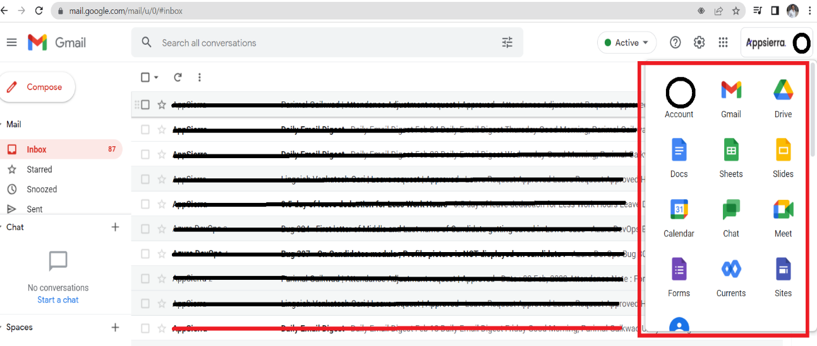

* **Actions class**

1)Practice Drag And Drop action :

Demo site for practice : https://jqueryui.com/droppable/

2)Practice Keyboard Events

Demo site for practice : <https://www.techlistic.com/p/selenium-practice-form.html>

3)Practice Double click action.

* **Window Handling**

1)Practice window handling operations

Demo site for practice : https://demoqa.com/browser-windows